Introduction to Machine Learning

Machine learning (ML) allows computers to learn and make decisions without being explicitly programmed.
It involves feeding data into algorithms to identify patterns and make predictions on new data. It is used in various applications like image recognition, speech processing, language translation, recommender systems, etc. In this article, we will see more about ML and its core concepts.

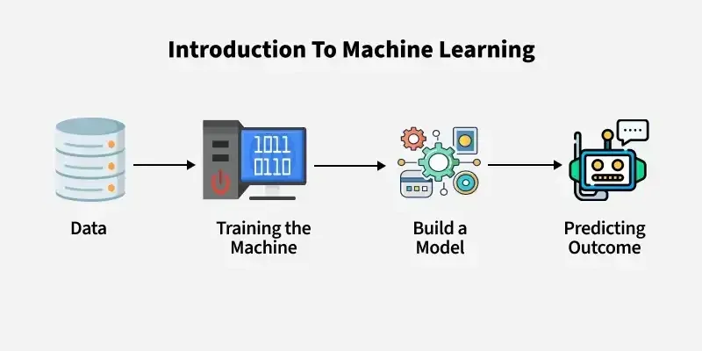

Why do we need Machine Learning?
Traditional programming requires exact instructions and doesn’t handle complex tasks like understanding images or language well. It can’t efficiently process large amounts of data. Machine Learning solves these problems by learning from examples and making predictions without fixed rules. Let's see various reasons why it is important:
1. Solving Complex Business Problems
Traditional programming struggles with tasks like language understanding and medical diagnosis. ML learns from data and predicts outcomes easily.
Examples:
- Image and speech recognition in healthcare.
- Language translation and sentiment analysis.
2. Handling Large Volumes of Data
The internet generates huge amounts of data every day. Machine Learning processes and analyzes this data quickly by providing valuable insights and real-time predictions.
Examples:
- Fraud detection in financial transactions.
- Personalized feed recommendations on Facebook and Instagram from billions of interactions.
3. Automate Repetitive Tasks
ML automates time-consuming, repetitive tasks with high accuracy hence reducing manual work and errors.
Examples:
- Gmail filtering spam emails automatically.
- Chatbots handling order tracking and password resets.
- Automating large-scale invoice analysis for key insights.
4. Personalized User Experience
ML enhances user experience by tailoring recommendations to individual preferences. It analyze user behavior to deliver highly relevant content.
Examples:
- Netflix suggesting movies and TV shows based on our viewing history.
- E-commerce sites recommending products we're likely to buy.
5. Self Improvement in Performance
ML models evolve and improve with more data helps in making them smarter over time. They adapt to user behavior and increase their performance.
Examples:
- Voice assistants like Siri and Alexa learning our preferences and accents.
- Search engines refining results based on user interaction.
- Self-driving cars improving decisions using millions of miles of driving data.

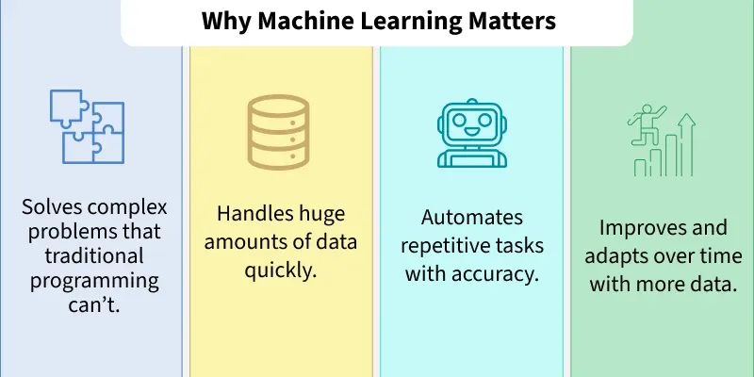

What Makes a Machine "Learn"?
A machine "learns" by identifying patterns in data and improving its ability to perform specific tasks without being explicitly programmed for every scenario. This learning process helps machines to make accurate predictions or decisions based on the information they receive. Unlike traditional programming where instructions are fixed, ML allows models to adapt and improve through experience.
Here is how the learning process works:
- Data Input: Machine needs data like text, images or numbers to analyze. Good quality and enough quantity of data are important for effective learning.
- Algorithms: Algorithms are mathematical methods that help the machine find patterns in data. Different algorithms help different tasks such as classification or regression.
- Model Training: During training, the machine adjusts its internal settings to better predict outcomes. It learns by reducing the difference between its predictions and actual results.
- Feedback Loop: Machine compares its predictions with true outcomes and uses this feedback to correct errors. Techniques like gradient descent help it update and improve.
- Experience and Iteration: Machine repeats training many times with data helps in refining its predictions with each pass, more data and iterations improve accuracy.
- Evaluation and Generalization: Model is tested on unseen data to ensure it performs well on real-world tasks.
Machines "learn" by continuously increasing their understanding through data-driven iterations like how humans learn from experience.
Importance of Data in Machine Learning
Data is the foundation of machine learning (ML) without quality data ML models cannot learn, perform or make accurate predictions.
- Data provides the examples from which models learn patterns and relationships.
- High-quality and diverse data improves how well models perform and generalize to new situations.
- It helps models to understand real-world scenarios and adapt to practical uses.
- Features extracted from data are important for effective training.
- Separate datasets for validation and testing measure how well the model works on unseen data.
- Data drives continuous improvements in models through feedback loops.

Types of Machine Learning

There are three main types of machine learning which are as follows:

1. Supervised learning
Supervised learning trains a model using labeled data where each input has a known correct output. The model learns by comparing its predictions with these correct answers and improves over time. It is used for both classification and regression problems.
Example: Consider the following data regarding patients entering a clinic. The data consists of the gender and age of the patients, and each patient is labeled as "healthy" or "sick".

Gender | Age | Label
M | 48 | sick
M | 67 | sick
F | 53 | healthy
M | 49 | sick
F | 32 | healthy
M | 34 | healthy
M | 21 | healthy

In this example, supervised learning is to use this labeled data to train a model that can predict the label ("healthy" or "sick") for new patients based on their gender and age. For example, if a new patient i.e Male with 50 years old visits the clinic, model can classify whether the patient is "healthy" or "sick" based on the patterns it learned during training.

2. Unsupervised learning:
Unsupervised learning works with unlabeled data where no correct answers or categories are provided. The model's job is to find the data, hidden patterns, similarities or groups on its own. This is useful in scenarios where labeling data is difficult or impossible. Common applications are clustering and association.
Example: Consider the following data regarding patients. The dataset has a unlabeled data where only the gender and age of the patients are available with no health status labels.
Gender | Age
M | 48
M | 67
F | 53
M | 49
F | 34
M | 21
Here unsupervised learning looks for patterns or groups within the data on its own. For example it might cluster patients by age or gender and grouping them into categories like "younger healthy patients" or "older patients" without knowing their health status.

3. Reinforcement Learning
Reinforcement Learning (RL) trains an agent to make decisions by interacting with an environment. Instead of being told the correct answers, agent learns by trial and error method and gets rewards for good actions and penalties for bad ones. Over time it develops a strategy to maximize rewards and achieve goals. This approach is good for problems having sequential decision making such as robotics, gaming and autonomous systems.
Example: While Identifying a Fruit, system receives an input for example an apple and initially makes an incorrect prediction like "It's a mango". Feedback is provided to correct the error "Wrong! It's an apple" and the system updates its model based on this feedback.
Over time it learns to respond correctly that "It's an apple" when getting similar inputs and also improves accuracy.

